**Problem Statement:**

You work for XYZ Corporation. To maintain the security of the AWS account and

the resources you have been asked to implement a solution that can help easily

recognize and monitor the different users. Also, you will be monitoring the

machines created by these users for any errors or misconfigurations.

**Tasks To Be Performed:**

1. Create a dashboard which lets you check the CPU utilization and

networking for a particular EC2 instance

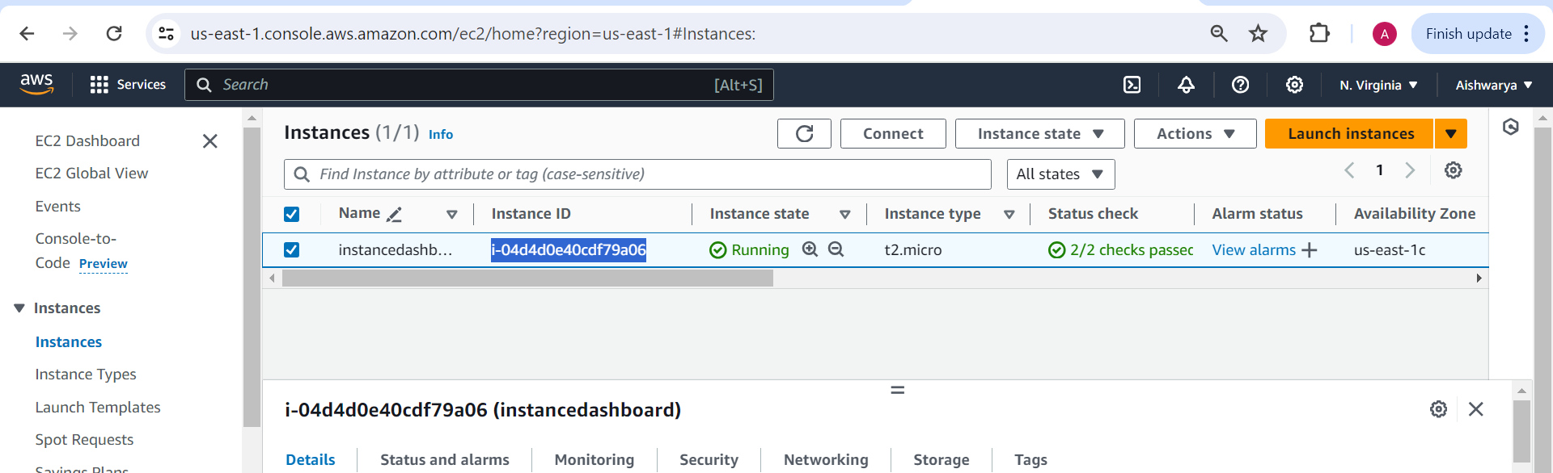

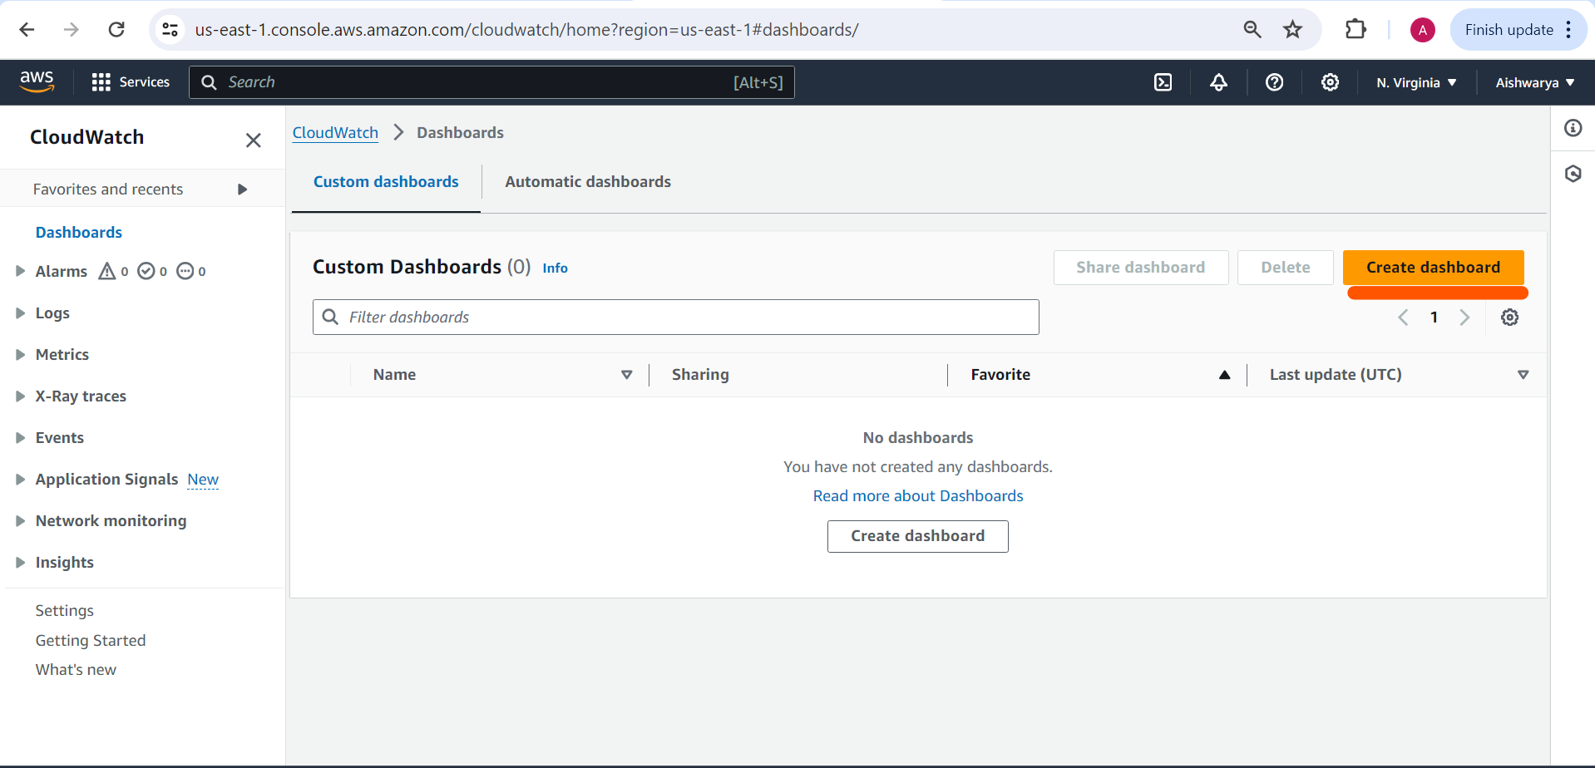

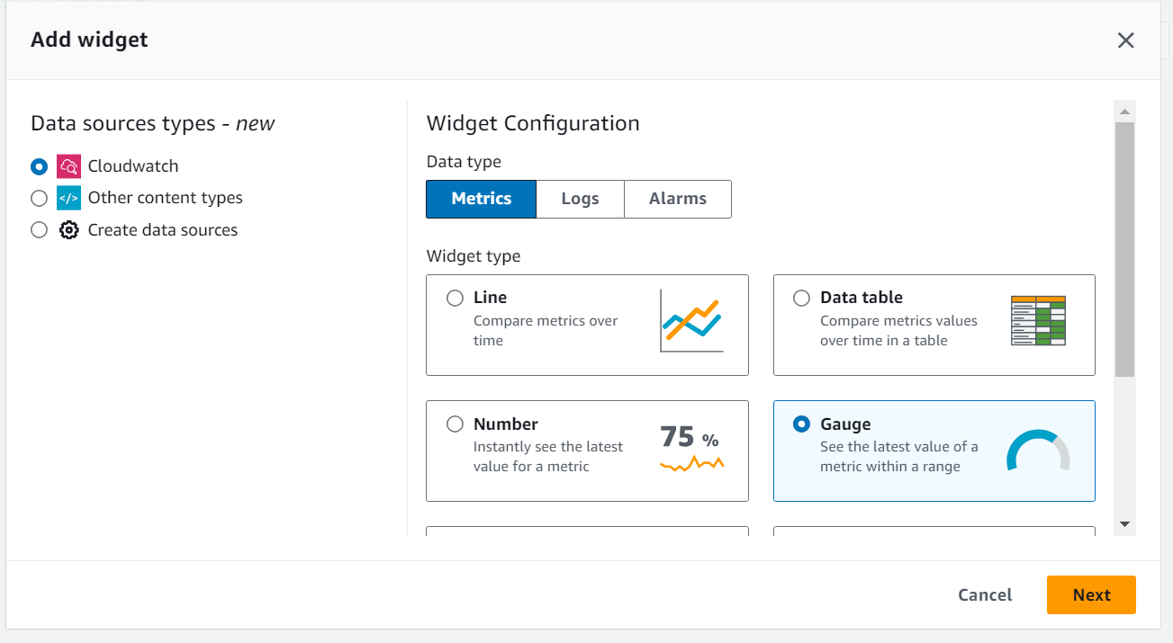 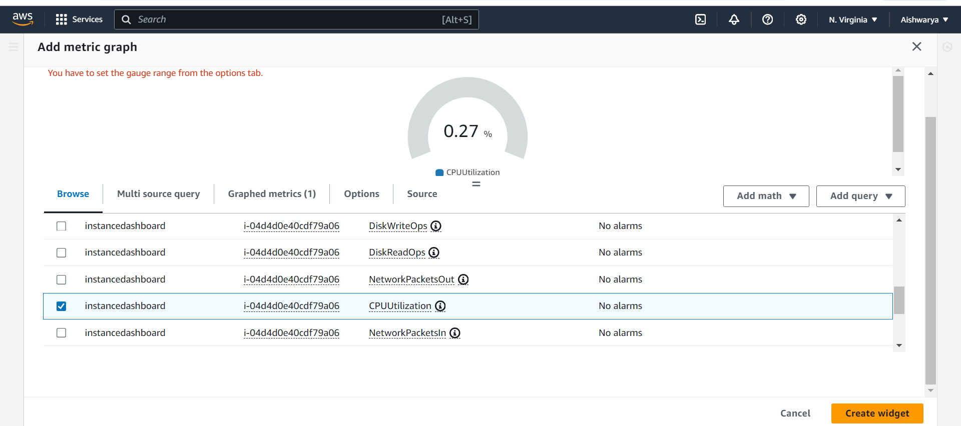 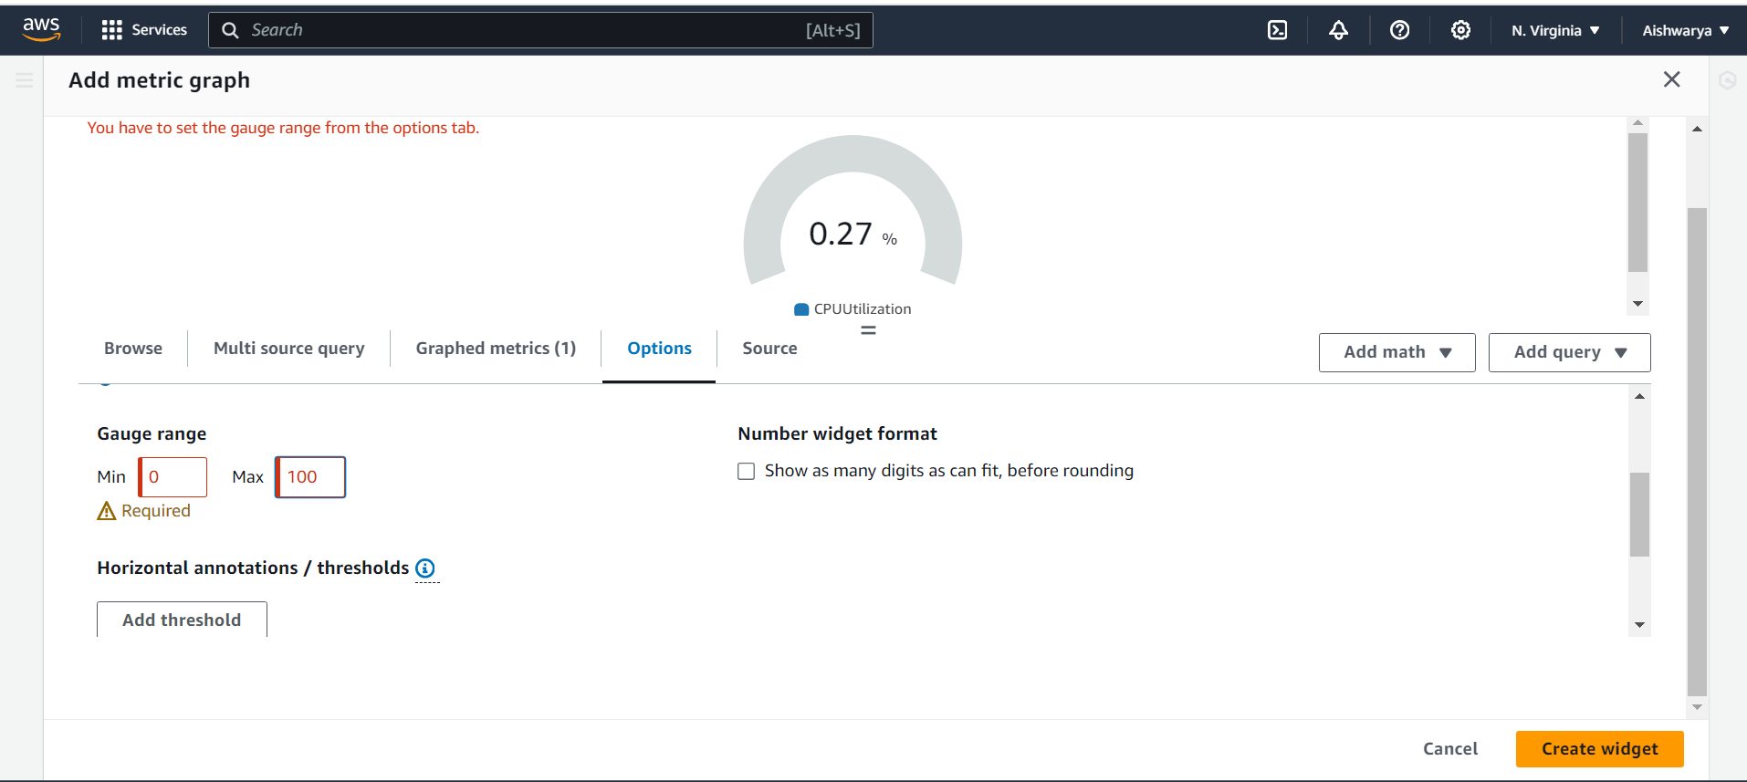

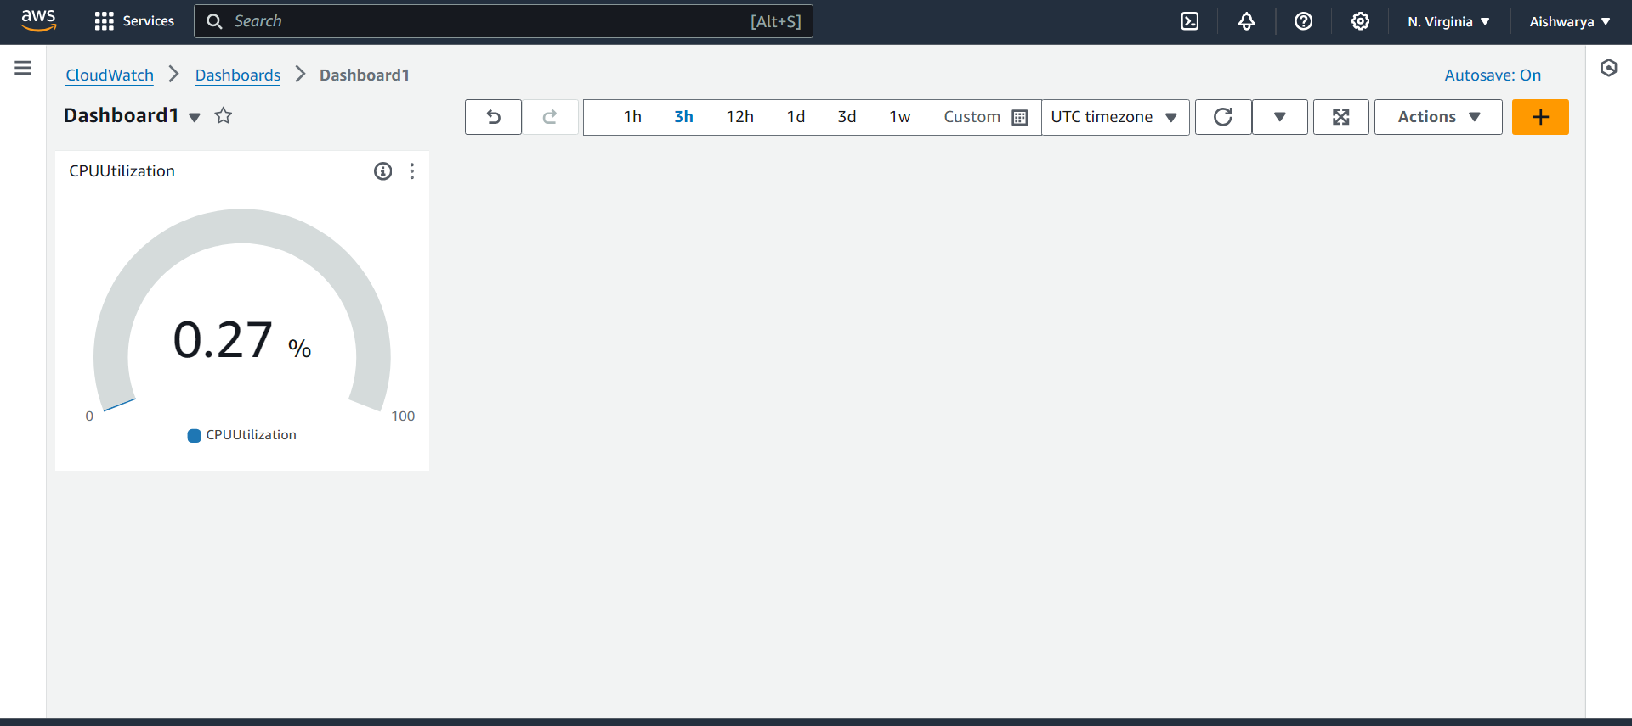

Networking

